CO1-AT1-SHORT ANSWER

NAME:M.SADHANA
REG.NO:192524386
COURESE CODE:ITA0508
COURSE:COMPUTER VISION
- A camera captures an image that appears blurred due to improper sampling. Explain how sampling affects image quality and suggest a method to correct it.

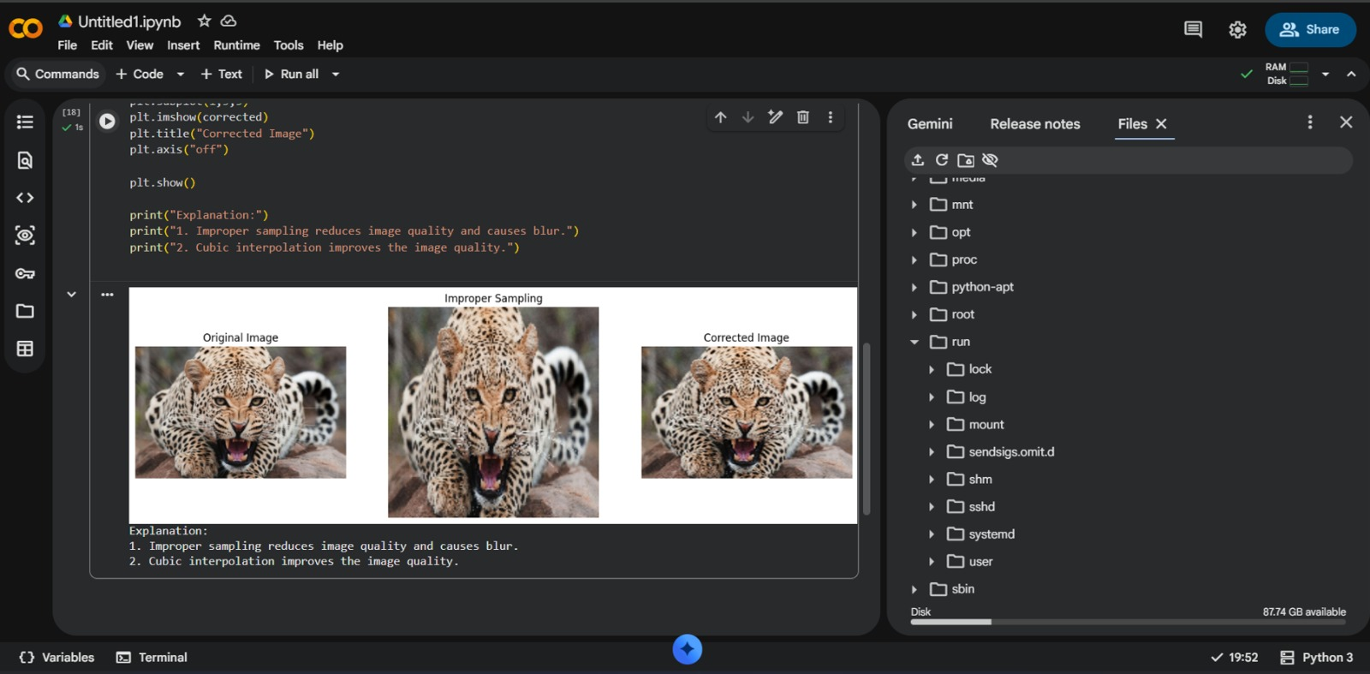

- Given a real-world scene captured under low light, describe how the image sensing and acquisition process influences the final digital image.

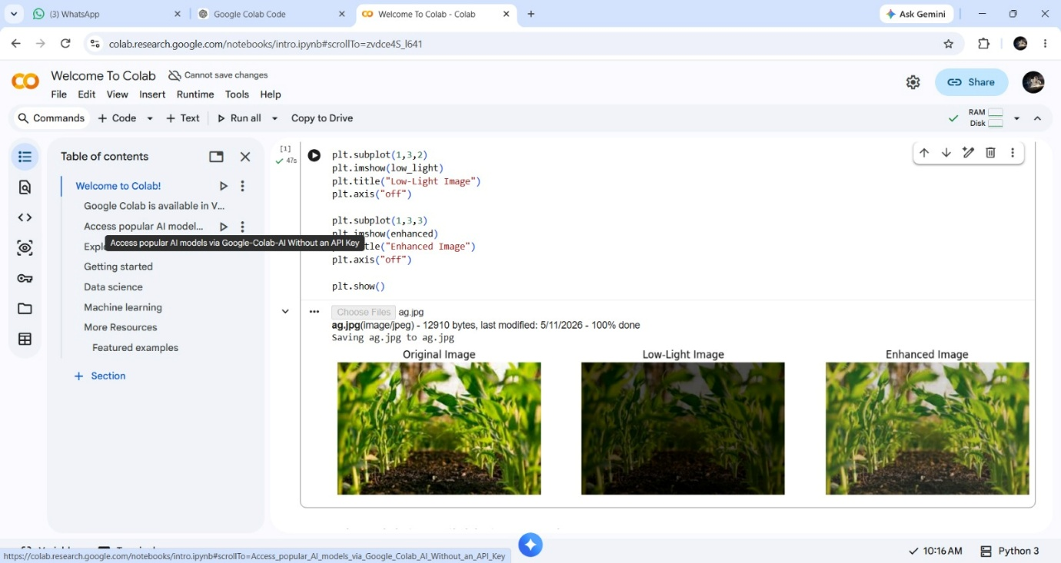

- An image shows aliasing artifacts. Identify the cause using sampling and quantization concepts and propose a corrective approach.
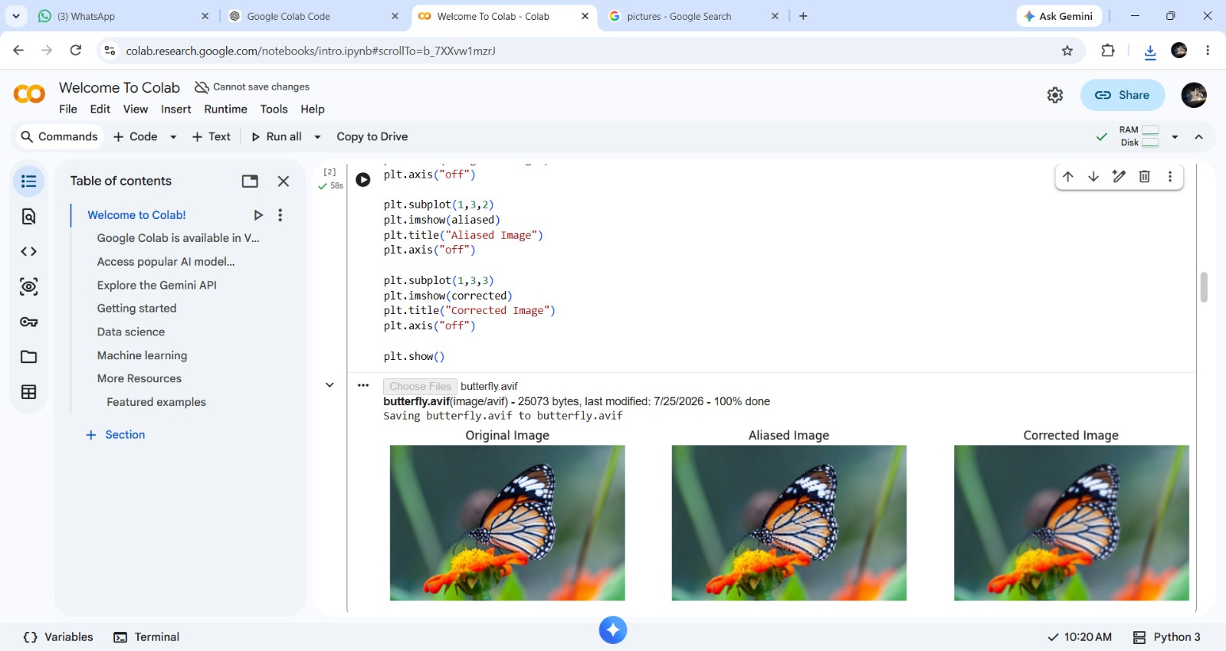

- Differentiate how pixel resolution and intensity resolution affect image representation in a practical application like medical imaging.

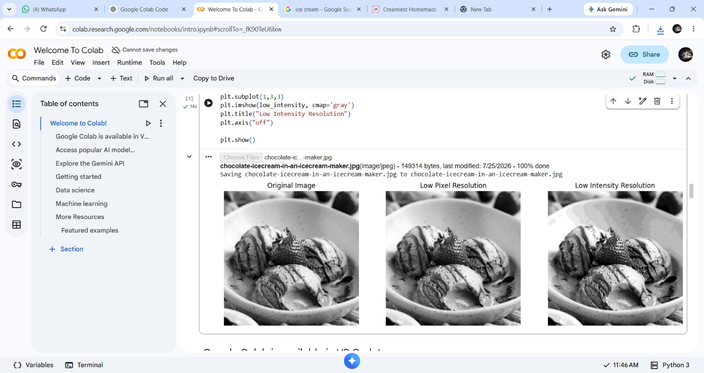

- A surveillance system requires real-time image processing. Classify the level of Computer Vision involved and justify your choice.

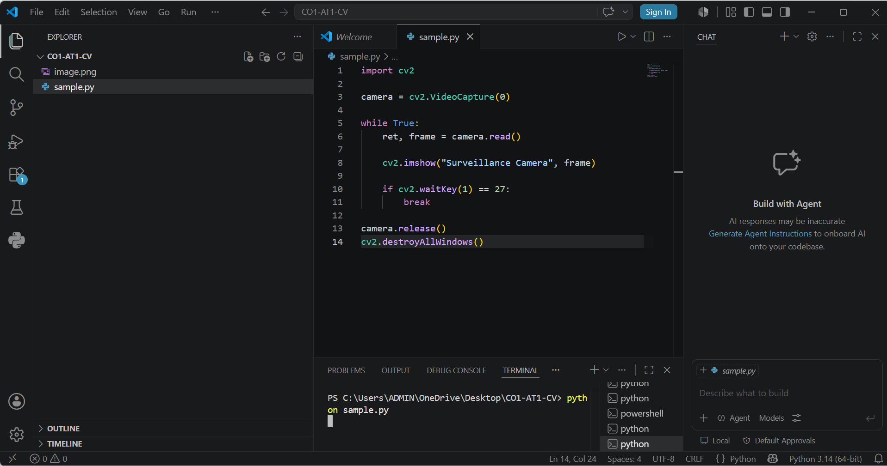
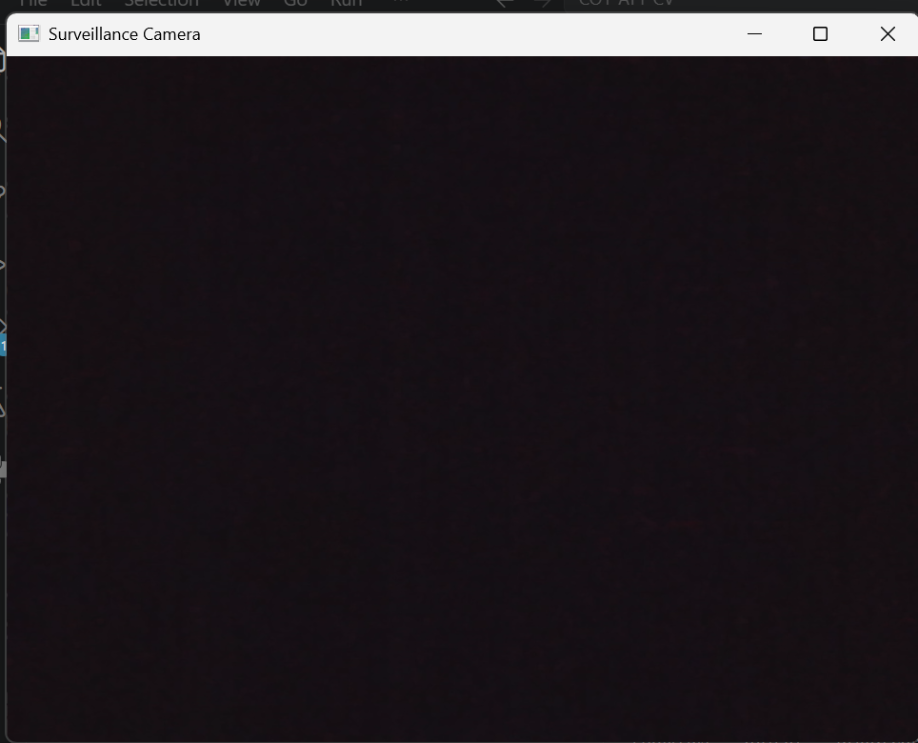

- Explain how image formation models help in improving image quality in applications such as autonomous driving.

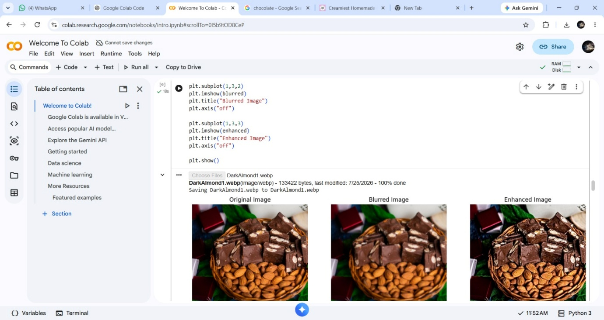
- A grayscale image is converted into a digital image. Describe the role of quantization in this process and its impact on image detail.

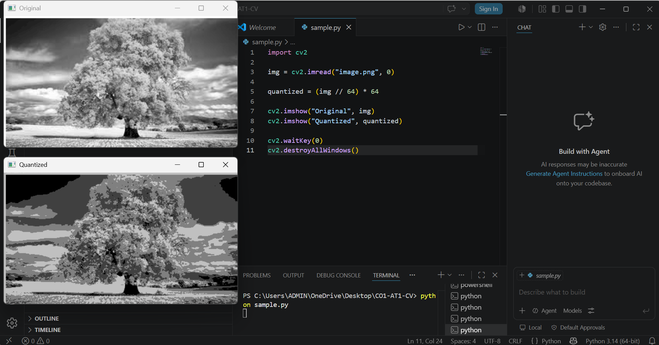
- Given a noisy image acquired from a sensor, explain how the acquisition process contributes to noise and how it can be minimized.

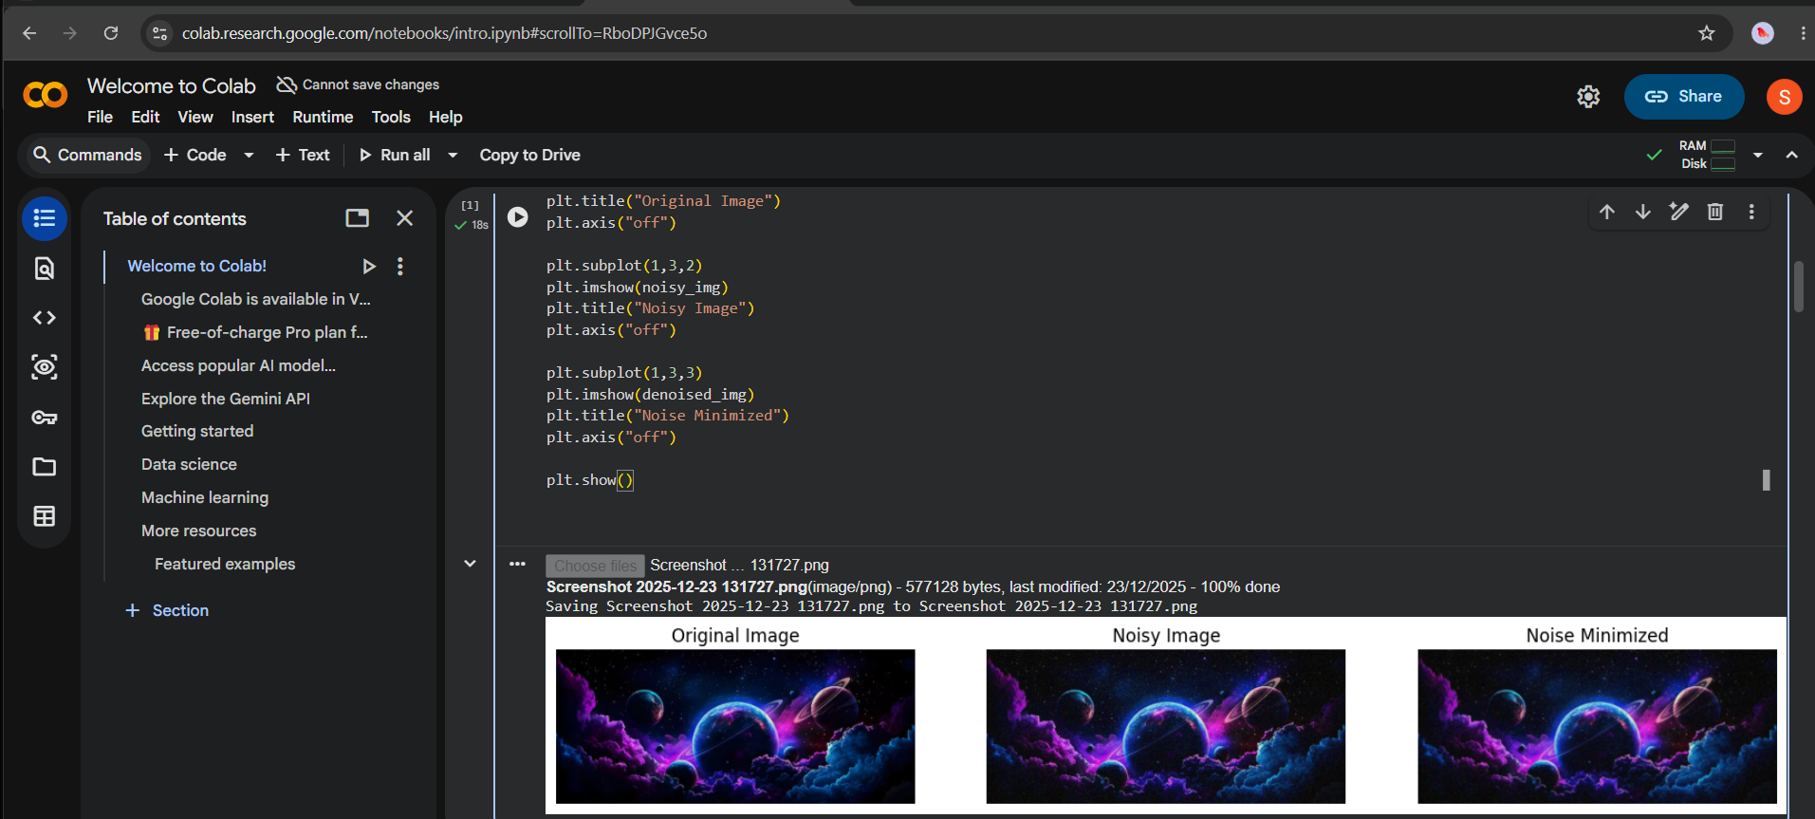
- In an application like facial recognition, explain how different levels of Computer Vision are involved from image acquisition to decision making.

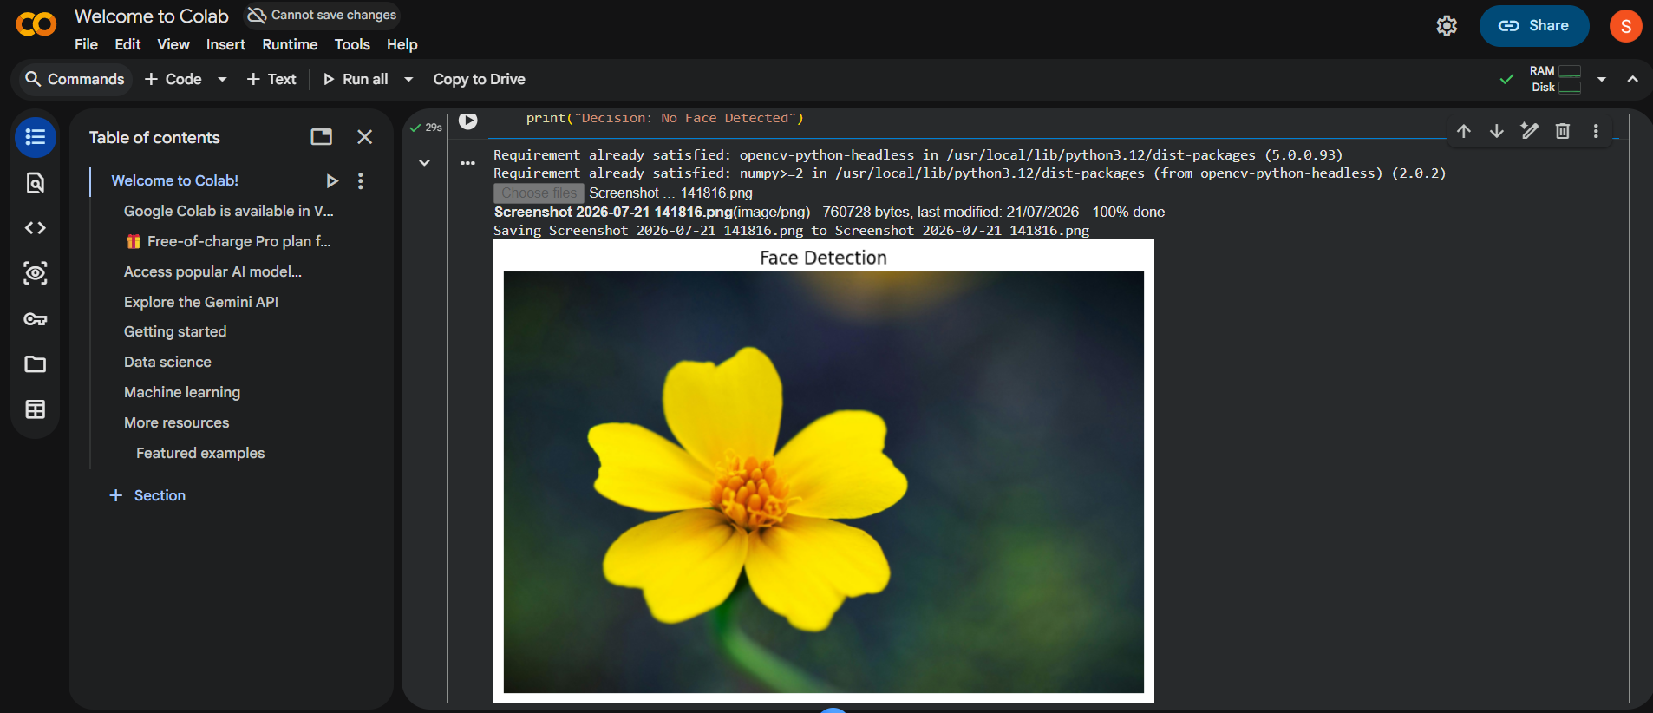
- An image captured with low resolution fails to detect objects clearly. Explain how sampling and image formation affect object visibility.
